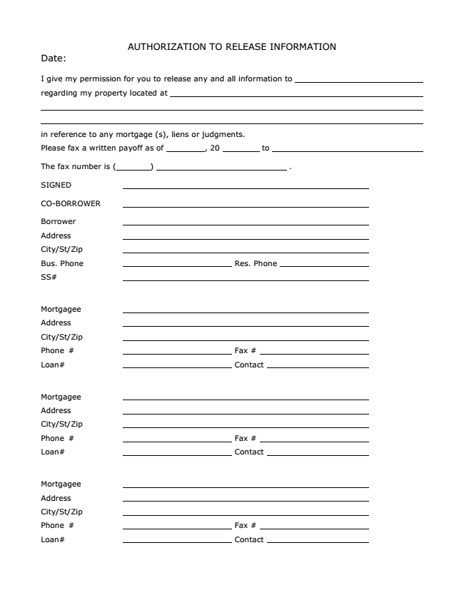
AUTHORIZATION TO RELEASE INFORMATION Date:
I give my permission for you to release any and all information to
regarding my property located at
in reference to any mortgage (s), liens or judgments.
Please fax a written payoff as of , 20 to
The fax number is ( ) .
SIGNED
CO-BORROWER
Borrower
Address
City/St/Zip
Bus. Phone Res. Phone
SS#
Mortgagee
Address
City/St/Zip
Phone # Fax #
Loan# Contact
Mortgagee
Address
City/St/Zip
Phone # Fax #
Loan# Contact
Mortgagee
Address
City/St/Zip
Phone # Fax #
Loan# Contact

